ASSIGNMENT – 2.4
Name:D.Sreeja
H NO:2303A51664
Batch-14
Task 1: Book Class Generation
❖ Scenario:
You are building a simple library management module.
❖ Task:
Use Cursor AI to generate a Python class Book with attributes title,
author,and a summary() method.
❖ Expected Output:
➢ Generated class
➢ Student commentary on code quality
PROMPT:
Generate a Python code withclass Book with attributes title, author,and a summary() method.
CODE:
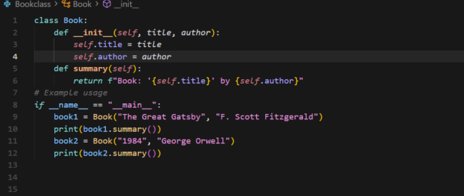
OUTPUT:
JUSTIFICATION:
This program is used to store book details like title and author in a single unit.
The class helps create multiple book objects without rewriting code.
The summary function prints book information in a clear and fixed format.
The main block runs the program and shows the output for different books.

Task 2: Sorting Dictionaries with AI
❖ Scenario:
You need to sort user records by age.
❖ Task:
Use Gemini and Cursor AI to generate code that sorts a list of
dictionaries by a key.
❖ Expected Output:
➢ Both AI outputs
➢ Comparison of clarity and performance
PROMPT:
Generate code that sorts a list of dictionaries by a key.
CODE FROM GEMINI:
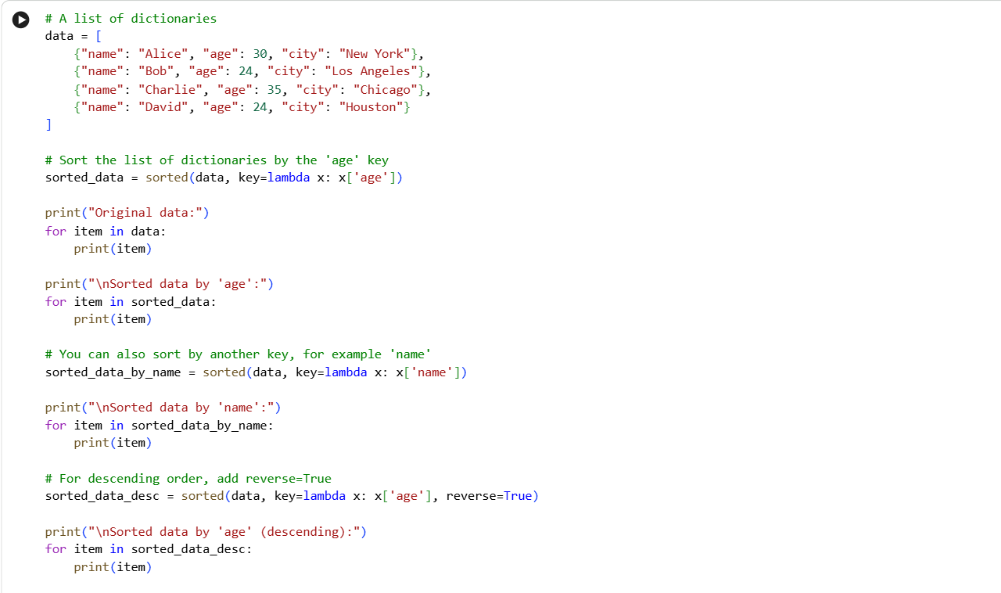
OUTPUT:
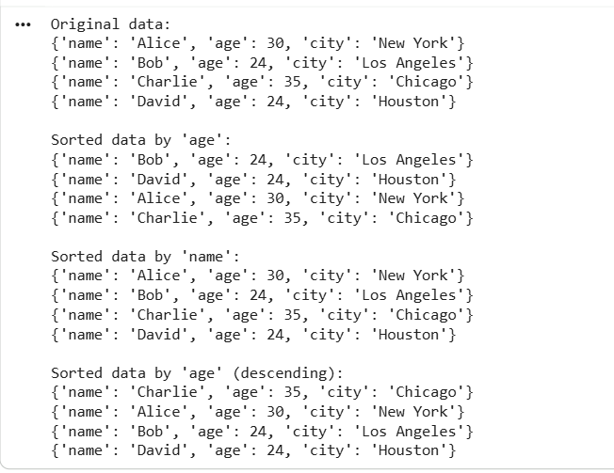
CODE FROM CURSOR AI:
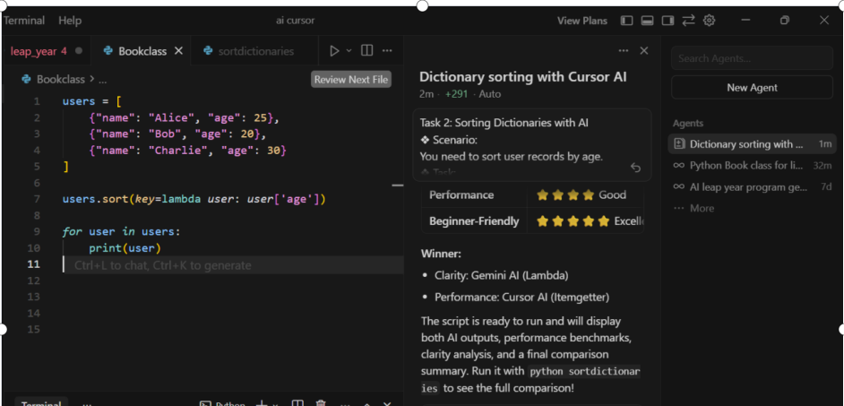
OUTPUT:
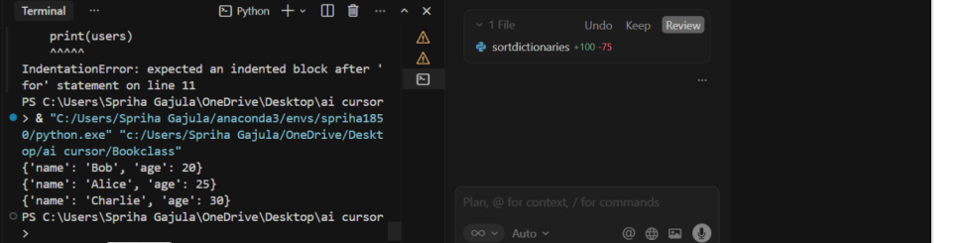
JUSTIFICATION:
Gemini AI provides simple and easy-to-understand code, making it suitable for beginners and quick learning.Cursor AI uses a function-based approach, which improves code reusability and maintainability.Both approaches have the same performance with time complexity of O(n log n).
Cursor AI includes basic error handling, making it safer for real-world applications.
Therefore, Gemini is ideal for learning, while Cursor AI is better for professional development
Task 3: Calculator Using Functions
❖ Scenario:
You are reviewing a basic calculator module.
❖ Task:
Ask Gemini to generate a calculator using functions and explain how it works.
❖ Expected Output:
➢ Calculator code
➢ AI explanation
➢ Screenshot
PROMPT:
Generate a calculator using functions.
CODE:
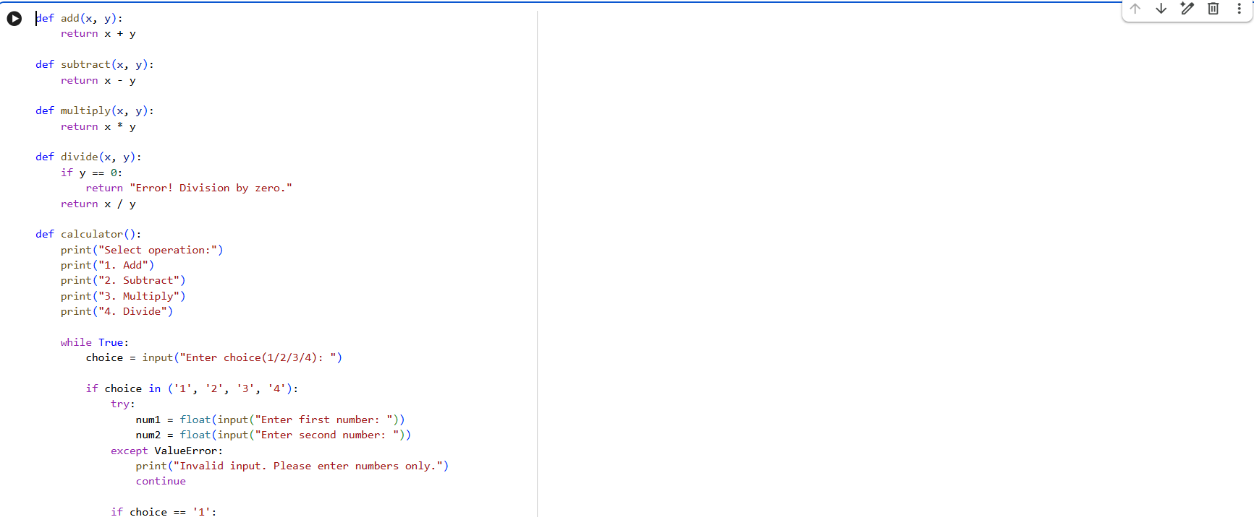
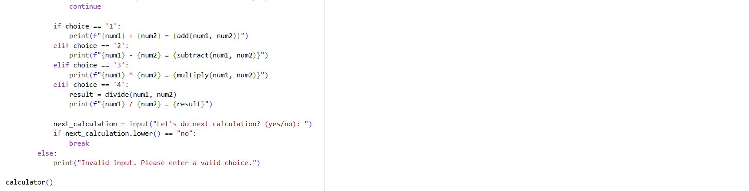
OUTPUT:
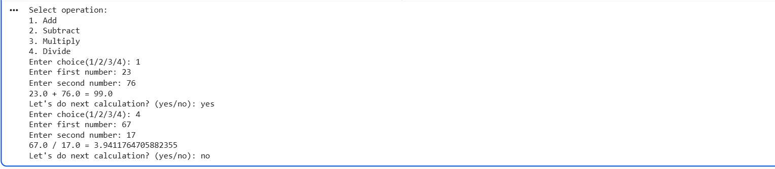
JUSTIFICATION:
Gemini AI generates simple and well-structured code using functions, which makes the calculator easy to understand and debug. Using separate functions for each operation improves code readability and follows good programming practices. The inclusion of a division-by-zero check enhances reliability. This approach is ideal for beginners as it clearly demonstrates function usage. Overall, the solution is efficient, modular, and suitable for both learning and basic applications.
Task 4: Armstrong Number Optimization
❖ Scenario:
An existing solution is inefficient.
❖ Task:
Generate an Armstrong number program using Gemini, then improve it using Cursor AI.
❖ Expected Output:
➢ Two versions
➢ Summary of improvements
PROMPT:
Generate an Armstrong number program using function
CODE USING GEMINI:
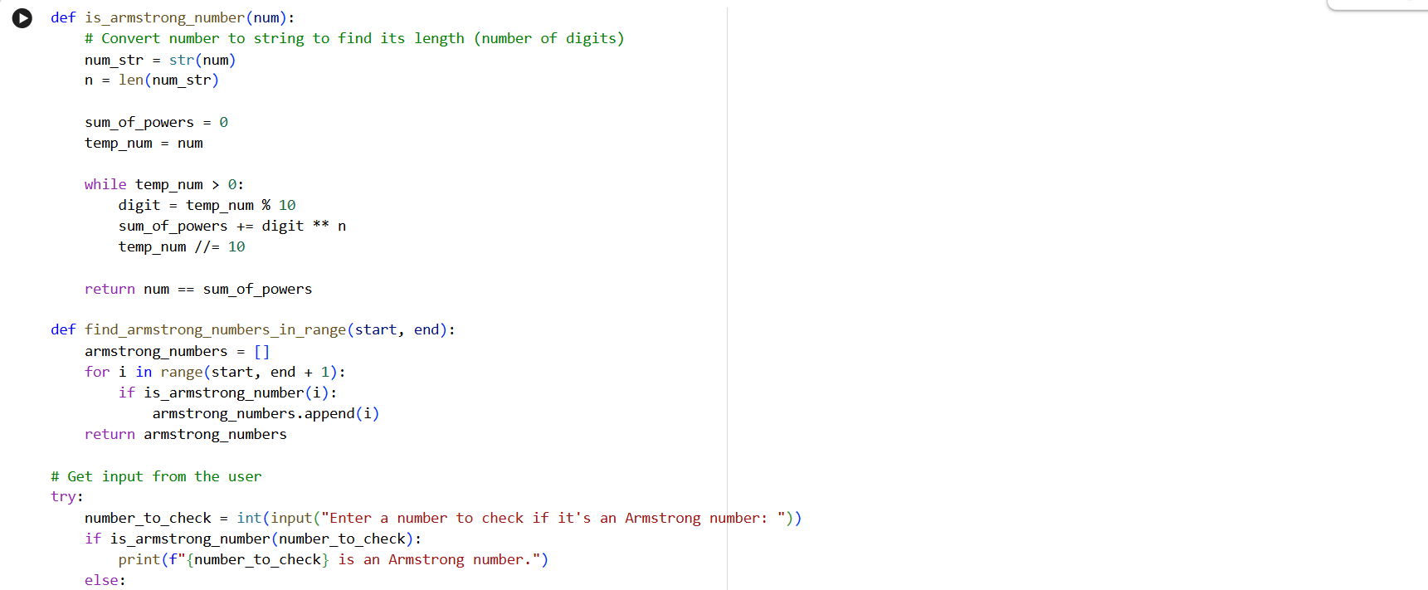
OUTPUT:
IMPROVEMENT CODE OF CURSOR AI:
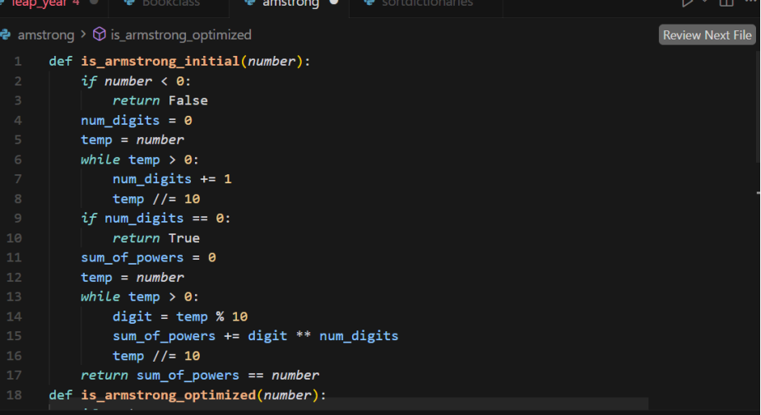
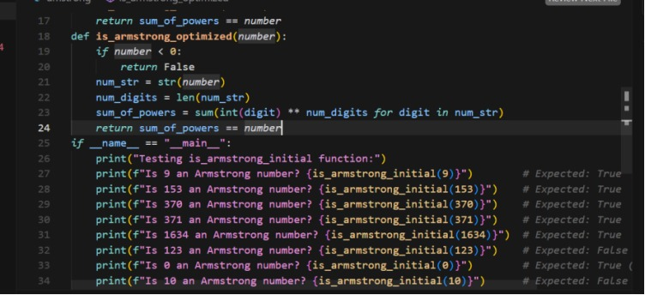
OUTPUT:
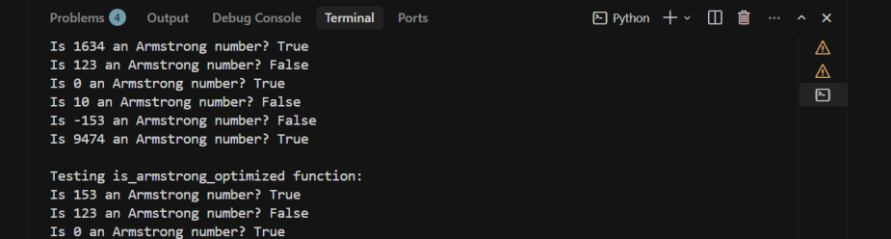
JUSTIFICATION:
Gemini AI provides a simple and beginner-friendly solution that is easy to understand but limited in flexibility. Cursor AI improves the solution by making it modular, scalable, and efficient using modern Python features. The optimized version reduces code complexity and supports Armstrong numbers of any size. Using functions also improves readability and reuse. Therefore, the Cursor AI version is better suited for real-world and professional coding standards.

